**SPRINT DELIVERY 3**

**TEAM ID: PNT2022TMID25041**

**ESTABLISHING THE TEXT-TO-SPEECH SERVICE**

**INSTALLATION OF WATSON VERSION:**

**CODE:**

pip install --upgrade "ibm-watson>=6.1.0"

**RESULT:**

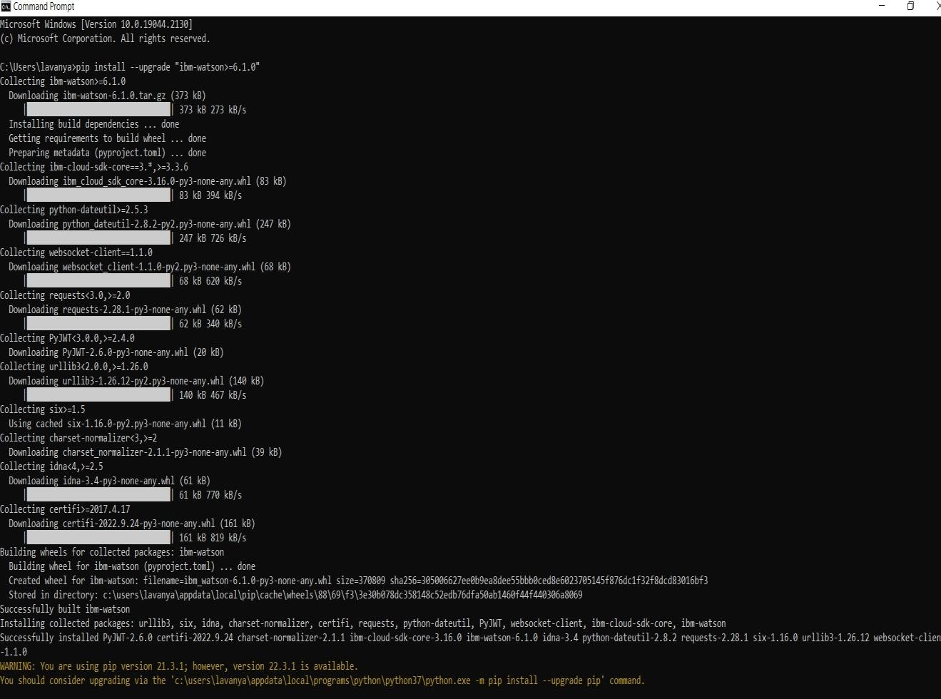

**COPYING CREDENTIALS FOR API AND URL:**

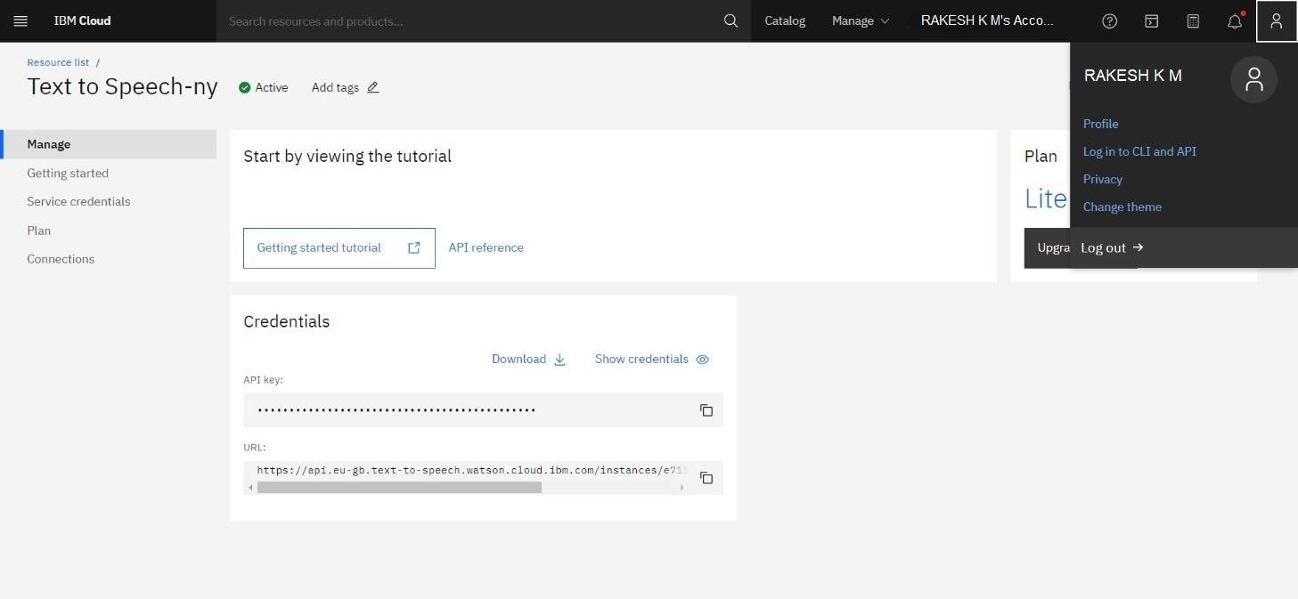

**PROGRAM FOR ACESSING APIs OF TTS SERVICE: from ibm_watson import TextToSpeechV1**

**from ibm_cloud_sdk_core.authenticators import IAMAuthenticator authenticator = IAMAuthenticator('7NcRcpMT221nhk1kB5DTsWpK- GQgjKFaWKa7Ao1BU7zQ')**

**text_to_speech = TextToSpeechV1( authenticator=authenticator)**

**text_to_speech.set_service_url('https://api.eu-gb.text-to- speech.watson.cloud.ibm.com/instances/e7133289-0146-4193-a7d5- b354d6831556')**

**with open('para.wav', 'wb') as audio_file:**

**audio_file.write(text_to_speech.synthesize('its the time to take paracetomal', voice='en-US_AllisonV3Voice', accept='audio/wav').get_result().content) EXECUTION AND RUN:**

